## Are females risk averse? Case of young adults in Sri Lanka

## *S. K. Jayaweera, L. T. Silva and J. M. Perera

*Department of Applied Science, University of Wayamba, Sri Lanka*

*\*jayaw2015@gmail.com*

**Abstract**

There is considerable interest in factors that influence individuals' decision making behaviour in risky contexts. According to the studies conducted in Western context, educational background can be considered one of the significant demographic factors in determining risk behaviour of individuals. The differences in behaviour according to the educational background can have important implications for economic outcomes including occupational choice, investment and consumption choices and insurance coverage. Supporting this real world scenario, some studies and meta-analysis carried out in the Western context find that individuals with different educational backgrounds tend to act in different ways when confronted with decisions under risk. However, only limited studies have been conducted in an Asian developing country setting about the factors which determine risky decision making scenarios. Therefore, the objective of the research was to assess whether there is a significant difference in risk behaviour of young adults according to their educational background in a developing country setting. A cross sectional study was carried out among young adults in Sri Lanka from five state universities. They were analyzed to assess their likelihood of engaging in risk related activities associated with their day to day life. A widely used behavioural model was used to assess the risk behviour of young adults in an Asian context. Initial analysis reveals there is a significant difference in the risk behaviour according to the educational background.

**Keywords:** Risk aversion, Risk behaviour, Youth

**Introduction**  
From the evolution of mankind, human beings have been known to be risk takers, and this behavioural trait has enabled society to develop knowledge and expertise to dramatically improve the overall living standards in the world (Libby & Fishburn, 1977). Risk has been defined in physiological, financial, economic and even in general terms. In many aspects of life, an individual makes choices about whether to avoid risk or accept risk (Morris et al., 2012). Research suggests that risk behaviour of teenagers and young adults around the world have progressively escalated over the past few decades (Chown, 2014). Risk has become a dominant preoccupation within Western society towards the end of the 20th century, to the point where we are increasingly risk tolerant and tend to accept the uncertainty that is associated with it. There is considerable interest in the factors that influence individuals' decision making behaviour in risky contexts, which is referred to as risk behaviour (Blackwell et al., 2001). Among a pool of demographic factors such as age, gender, income level, marital status and family background, educational background is one of the most significant demographic factors in determining risk behaviour of individuals. Studies have recognized important risk-related differences based on educational background (Dohmen et al., 2011).

Much progress has been made on developing empirical measures of individual risk attitudes, with the aim of capturing this important component of individual heterogeneity (Bruhin et al., 2007), but many questions remain unresolved.

**Methodology**

In order to assess validity of this hypothesis in an Asian developing country context, a cross sectional study was carried out in five Sri Lankan state universities.

Formation of the hypothesis:

H0: There is no difference in risk behaviour across the categories of educational stream

H1: There is a significant difference in risk behaviour across the categories of educational stream.

Risk behavior of young adults from five state universities from different faculties were analyzed to assess their likelihood of engaging in risk related activities associated with their day to day life. Risk taking is not a single trait, but is a behavior influenced by characteristics of the situation, the decision maker and the interactions between situation and decision maker. Understanding the mechanisms behind risk taking, who takes risks when and why, is particularly important when the goal is to influence and modify the behavior (Reyna and Rivers, 2008)

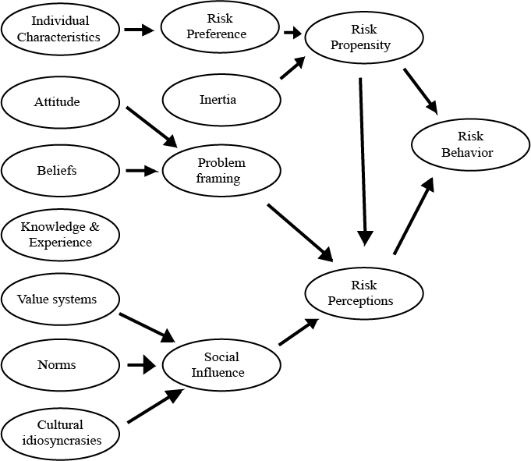

**Figure 1: Behavioural risk assessment model**

Figure 1, shows a behavioural model conceptualized by Brown (2015) primarily based on work done by Sitkin & Pablo (1992) and using other existing risk behavior models. The model was designed to evaluate the risk behaviour of young adults in Sri Lanka to establish the relationship between individual characteristics, external stimuli and risk behaviour. The results presented indicated that risk behaviour is determined by two major individual factors, namely risk propensity and risk perception. Risk propensity was found to be positively related to risk-taking behaviour whereas risk perception was negatively related to risk-taking behavior.

**Results**

The fact whether the educational stream has a significant impact on risk behaviour is tested using Kruskal-wallis test.

**Table 1: Risk behavior based on education stream**

|  |  |
| --- | --- |
|  | Risk behaviour |
| Chi-Square | 8.669 |
| df | 4 |
| Asymp. Sig. | 0.030 |
|  | |

The *p*-value of 0.03 indicates that there is no difference in risk behaviour based on educational background. Results indicate a strong positive impact of educational background on risk behaviour among young adults in Sri Lanka. Therefore, we can conclude that there is a significant difference in risk behaviour across the categories of educational stream.

The probability distribution of the risk behaviour educational stream wise can be depicted in Figure 2 below.

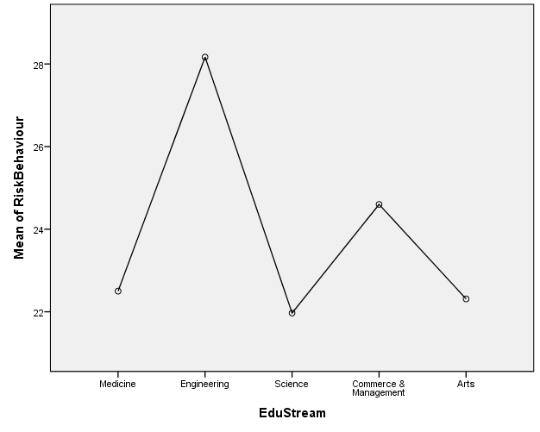

**Figure 2: Difference in risk behavior according to educational background**

**Conclusion**

Contribution to theory and practice is highlighted in the wide implications for many sectors in the economy. Understanding the difference in the human risk behaviour according to the educational background is important for various segments in corporate sector such as Finance, Marketing, Human Resource Management across industry. For instance, difference in investors' risk tolerance according to their educational background is an opportunity for investment firms, banks and regulators. To elaborate, being able to predict the investor behaviour correctly of individuals is a competitive advantage since it enables investment advisors and other financial firms to offer customized investment advices and bespoken products which are in line with the needs of their customers. Furthermore, for the studies on consumer behaviour adding the risk behaviour difference according to educational background would help firms and organizations improve their marketing strategies. Similarly, attitudes if differ according to the educational background of candidate could be important in certain job placements.

The study described in this paper pave the way for future studies and future research studies may precisely model the educational background differences in risk taking from different viewpoints. Therefore, the future research on risk behaviour studies are suggested to shed new light on broad areas such as academic fields, career choice, and financial domain with the educational level and the educational background differences in Sri Lankan context.

**References**

Blackwell, R. D., Miniard, P. W., & Engel, J. F. (2001). Consumer behavior 9th. South-Western Thomas Learning. Mason, OH.

Bruhin, A., Fehr-Duda, H., & Epper, T. (2007). Risk and Probability: Uncovering Heterogeneity in Probability Distortion (No. 0705). SOI Working Paper.

Dohmen, T., Falk, A., Huffman, D., Sunde, U., Schupp, J., & Wagner, G. G. (2011).

Individual risk attitudes: Measurement, determinants, and behavioral consequences. Journal of the European Economic Association, 9(3), 522-550.

Libby, R., & Fishburn, P. C. (1977). Behavioral models of risk taking in business decisions: A survey and evaluation. Journal of Accounting Research, 272-292.

Morris, J., Marzano, M., Dandy, N., & O’Brien, L. (2012). Theories and models of behaviour and behaviour change. Forest Research: Surrey, United Kingdom.

Reyna, V. F., & Rivers, S. E. (2008). Current theories of risk and rational decision making. Developmental review: DR, 28(1), 1.

Sitkin, S. B., & Pablo, A. L. (1992). Reconceptualizing the determinants of risk behavior. Academy of management review, 17(1), 9-38.